**RESTAURANT WEBSITE**

End Term Report

By

SECTION :- K18SJ

S.Sai Jyothi Swaroop

Reg.no:-11802400(24)

G.Konda Reddy

Reg.no:-11801541(34)

B.Chaitanya Reddy

Reg.no:-11805820(11)



Department of Intelligent Systems

School of Computer Science Engineering

Lovely Professional University, Jalandhar

**DECLARATION**

This is to declare that this report has been written by me/us. No part of the

report is copied from other sources. All information included from other sources

have been duly acknowledged. I/We aver that if any part of the report is found to be copied, I/we are shall take full responsibility for it.

S.Sai Jyothi Swaroop

Roll no:24

Sign:

B.Chaitanya Reddy

Roll no:11

Sign:

G.Konda Reddy

Roll no:34

Sign:

Date:22april 2019

Place:Jalandhar

**TABLE OF CONTENTS**

**Title**

1. Background and objectives of project

1.1.Introduction

1.2.Outcome Of The Project

2.Description Of The Project

2.1.Creating A Homepage

2.2.Modules

2.3.Explanation Of Each Module

3. DESCRIPTION OF WORK DIVISION

4. IMPLEMENTATION OF SCHEDULED WORK OF PROJECT

5.Analysis

**BONAFIDE CERTIFICATE**

Certified that this project report “RESTAURANT WEBPAGE” is the

bonafide work of “S.sai Jyothi swaroop, B.chaitanya Reddy, G,Konda Reddy” who carried out

the project work under my supervision.

Signature of the Supervisor

Name of supervisor

Academic Designation

ID of Supervisor

Department of Supervisor

**BACKGROUND AND OBJECTIVES OF THE PROJECT**

INTRODUCTION:-

RESTAURANT WEBPAGE carries about more than 10 lakhs online food booking and hotel

accommodation every day. The Computerised table Reservation System or online book-

ing facilitates the booking and cancellation of table or food from any of the 4000

terminals (i.e. booking window all over the countries). These booked or cancelled for online food delivery commencing in any part of within town and ending in any other part, with travel time .

With the help of online booking people can book their food online through internet, sitting in their home by a single click of mouse. Using their credit cards,e-wallets,people can easily get their foods done within minutes.In the given project we will going to give the explanation how the process is going on in online booking with the help of webpages which are similar to present in online. In upcoming pages we will see the webpages done by us where you can get a idea.

In this project we are used the HTML,CSS AND JAVA SCRIPT.

**OUTCOME OF THE PROJECT:**

The first and foremost outcome is the effective homepage which is similar is actual

homepage which is present in Retro application.The next finding the trains between the

source and destination.the form which is required to take the details from the coustmours.The

wep page and successfully interlinked the webpages to the homepage such as cheifs,about

contact us ,showing the showing gallery,booking a tables in page which is most essential page where the customer can clarify the doubts,rate us page where people can give their feedback,online delivery.

In this project we don’t have given servers so all the static pages and data in those are static

and small events are used in making effective.

**DESCRIPTION OF PROJECT:-**

The project is done by using hypertext markup language and

cascading style sheet which makes the webpage colorful and required

format and javascript.

The project consists of many webpages interlinked to the main

homepage.these done by using modules in their respective languages.

The parts in Homepage:

1.background

2.form

3.heading

4.listed items

5.footer

6.Padding

7.key-frames

8.buttons

9.image tages

10.Navigation bars

11.interlinking the pages

Explanation of each part :

1.background

The homepage is having a effective background image which is

related to our project.and this done by giving the attribute in css to the

body of the homepage

Written type of background image attribute in css is::

1.Background-image:url(“path of image”);

2.form

3.hovers

4.id’s

5.classes

6.document.get element by id

7.document.getelementbyclass name.

The most and essential thing in the project is creating a form which is

essential to take the data from the passenger.

In this form we used two text boxes for source and destination of the journey

and one for date and one select option for choosing the class.

<form>

<input type=”text” name=”Name”>

<input type=”text” name=”email”>

<textarea row=8 column=20></textarea>

<button type=”submit” ></button>

</form>

The output of form is:

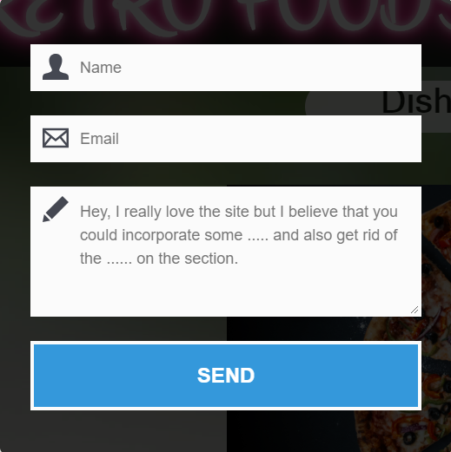

3.Heading:-

we used the “Rerto @easy way in seconds” in the homepage.

The code for this is:

In this project listed items are used to create the modules such as home

,about ,chefs ,gallery ,reserving table, online delivery ,contact us ,rate us, cuisine etc.

The code for writing listed items is:

<ul>

<li><a href="#">name of the module</a></li>

</ul>

The output is :

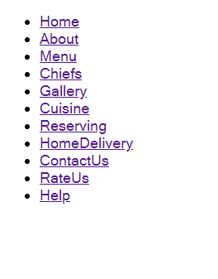

After using the css the output:



The code of css of above is:

.class1 li{

float:left;

display: inline;

padding:06px 16px 06px 16px;

border: solid 1px green;

background-color:#FA58D0;

text-align: center;

fon

}

5.footer:-

The footer is mainly used to write the copyright of the site.

The code for writing the footer is:

<footer class="footer">

<p>Rerto,<span class="foot">&trade;this site is since 1998</span></p>

</footer>

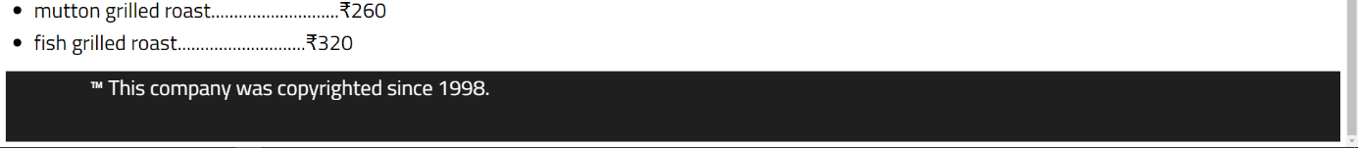

After this using modules the complete homepage is:

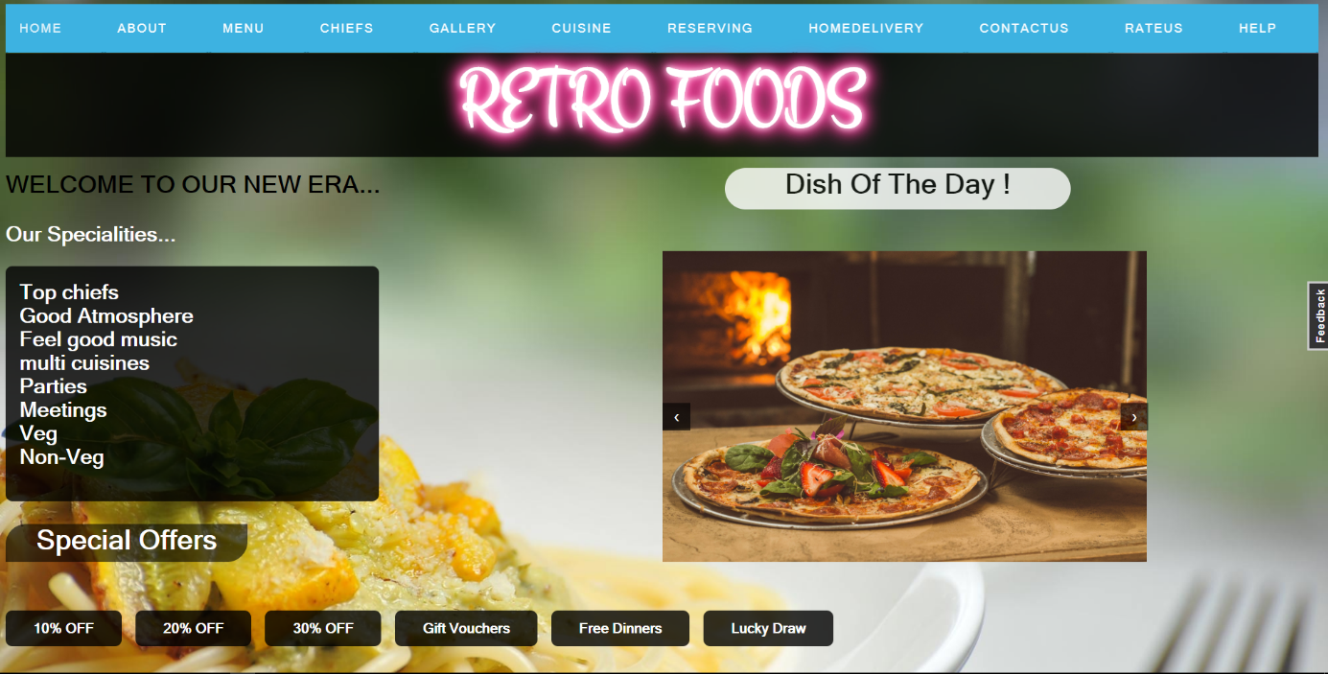

**THE MODULES ARE:-**

1.home

2.About

3.Chefs

4.Menu

5.Gallery

6.Cuisine

7.Reserving

8.Homedelivery

9.contact us

10.rate us

11.help.

Explanation :-

**1.Home:-**

The homepage is itself indicates the home module.

**2.About:**

This module indicates that the about the restaurant .The data enclosed in

Center alignment. and we given a video which describe briefly about the restaurant and an attractive nav bar and has an image to show about webpage and used different font styles using google fonts.

The code for making table eith data of trains which having name of

the train , from ,destination,arrival and departure time is:

<tr class="cs2">

<th>s.no</th>

<th>name of the train</th>

<th>from</th>

<th>to</th>

<th>time of departure</th>

<th>time of arrival</th>

</tr>

Here tr means table row and th means table heading.

The output is:

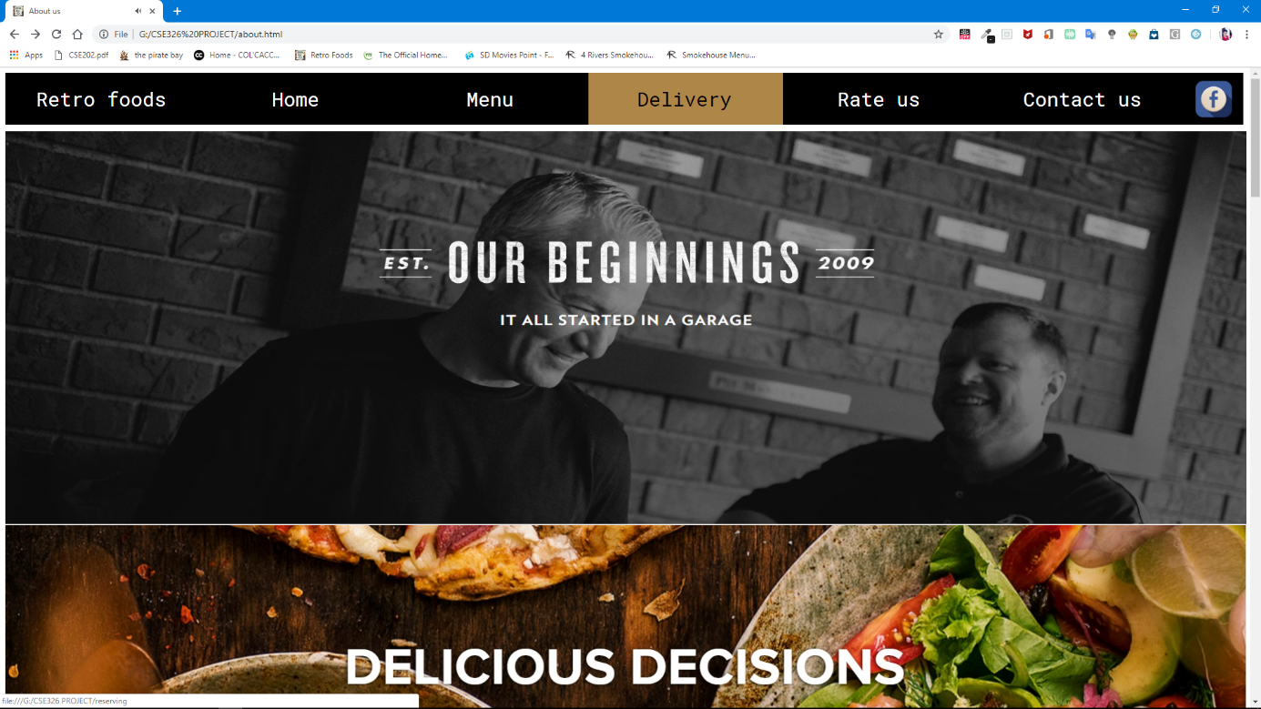

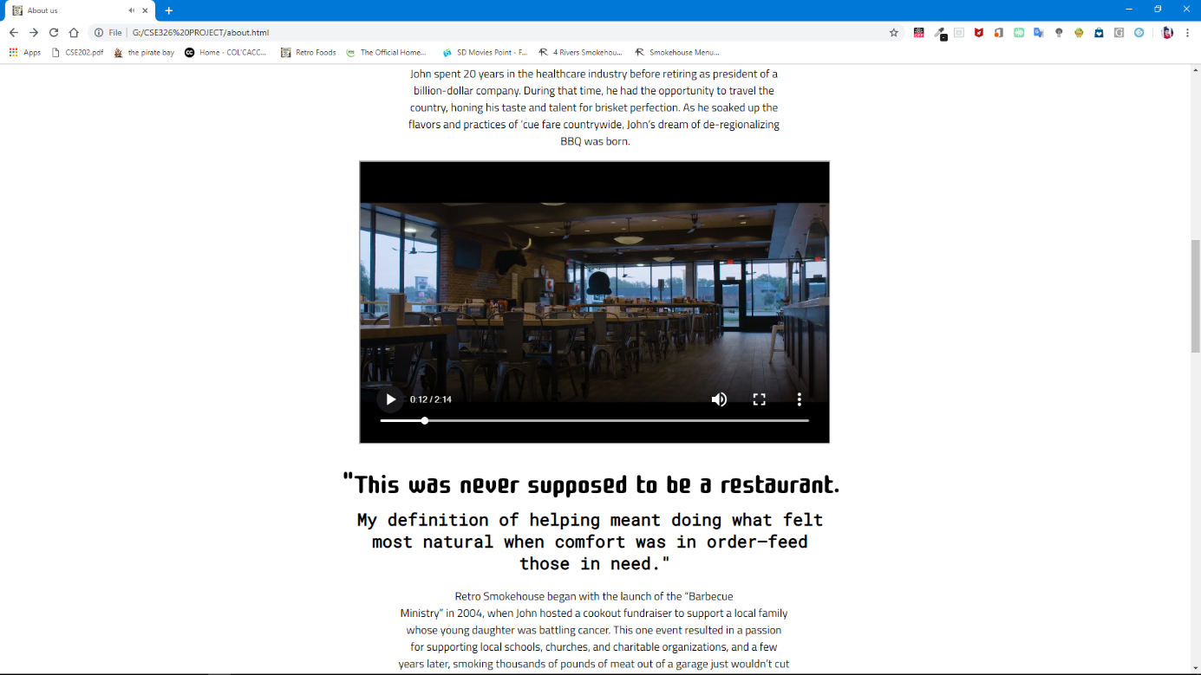

**3.Top chefs:-**

This page indicates the how the chefs are been selected are going in the

Rerto restaurant.The Cheifs like ,about them briefly and an place of the top chefs in the world and their skills and there images are done by using image tag and shaped well using the padding tags etc…

And nav bar is done with the black back ground andhover tags and used the logo of fb to connect with social media and made an attractive footer

In this project we given a small video by using tag given below:

<iframe src="123.mp4" width="500px" height="500px"></iframe>

And the paragraphs of announcements are given by using the tag:

<p> data of paragraph</p>

The output is:

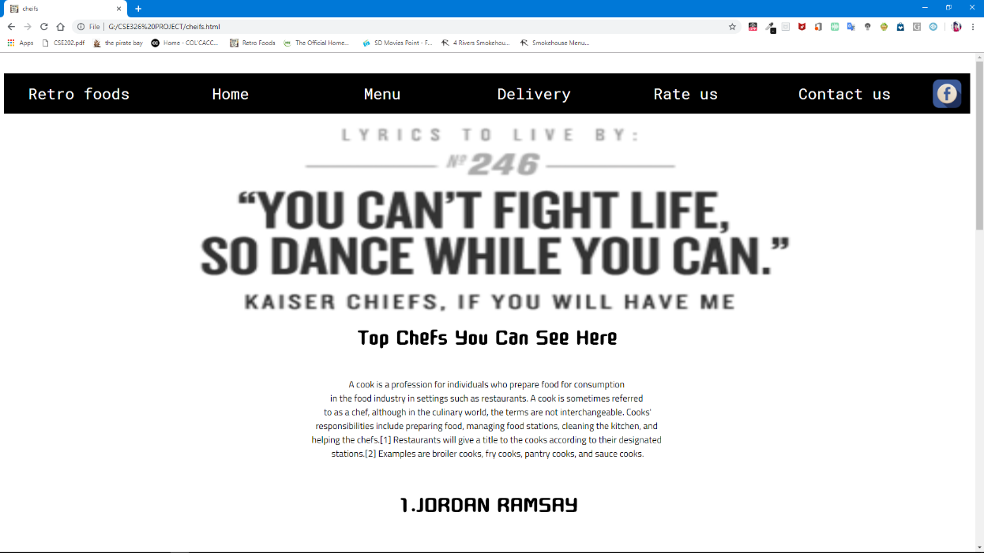

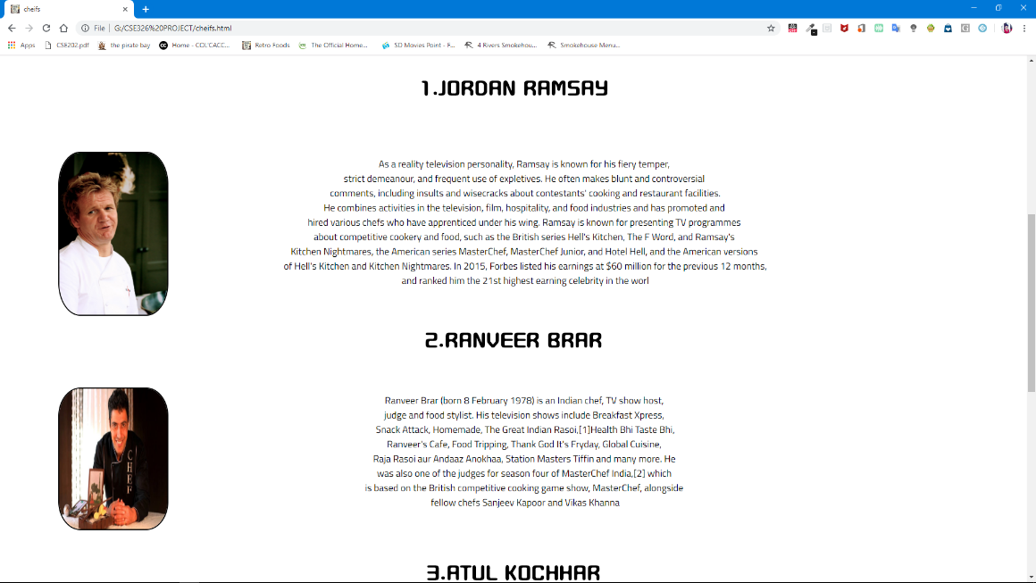

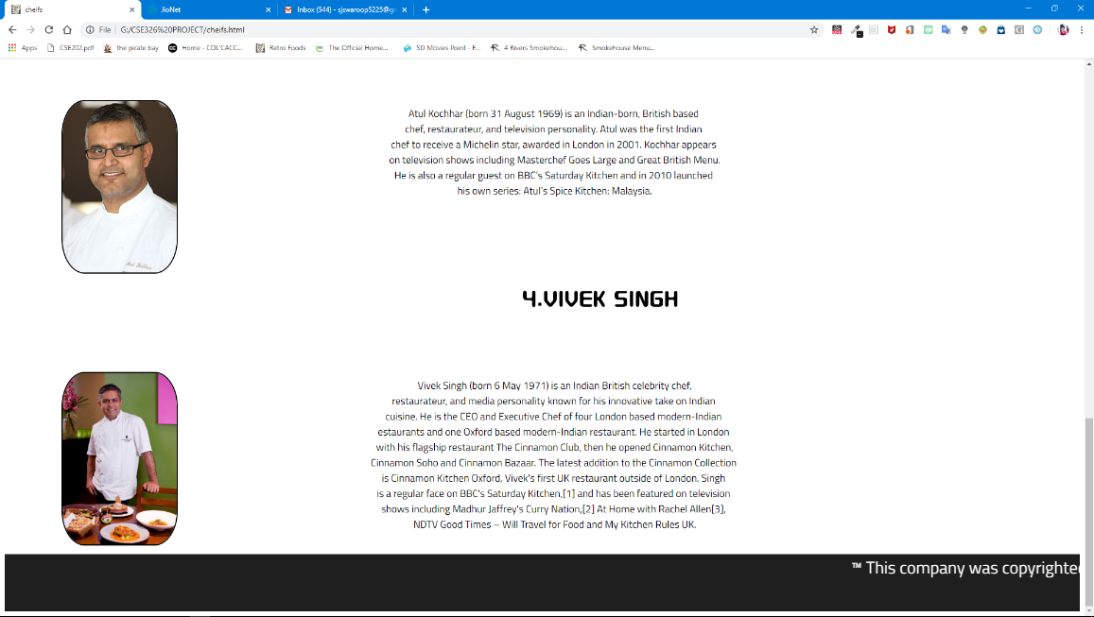

**4.Menu:-**

By the menu option you can see the hole cuisine and the varities of items .here we used many lines of coding ,we used ul tags ,li tags, nav bar different fonts h1 tags for headings and p tags and footer and getting the fonts online by emmbeding the links …..

The Output is:-

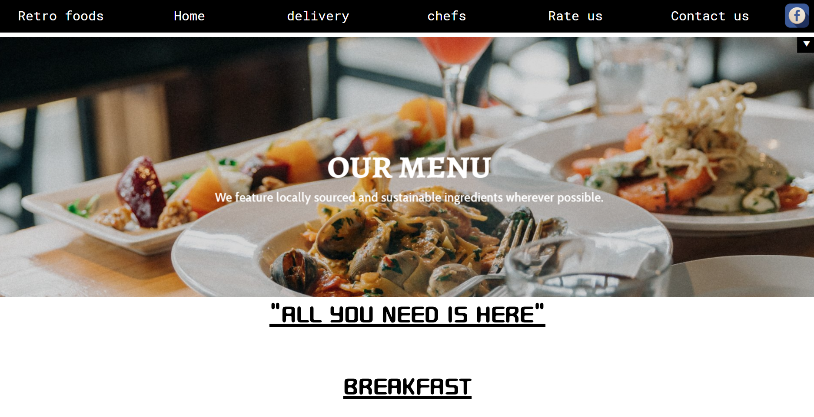 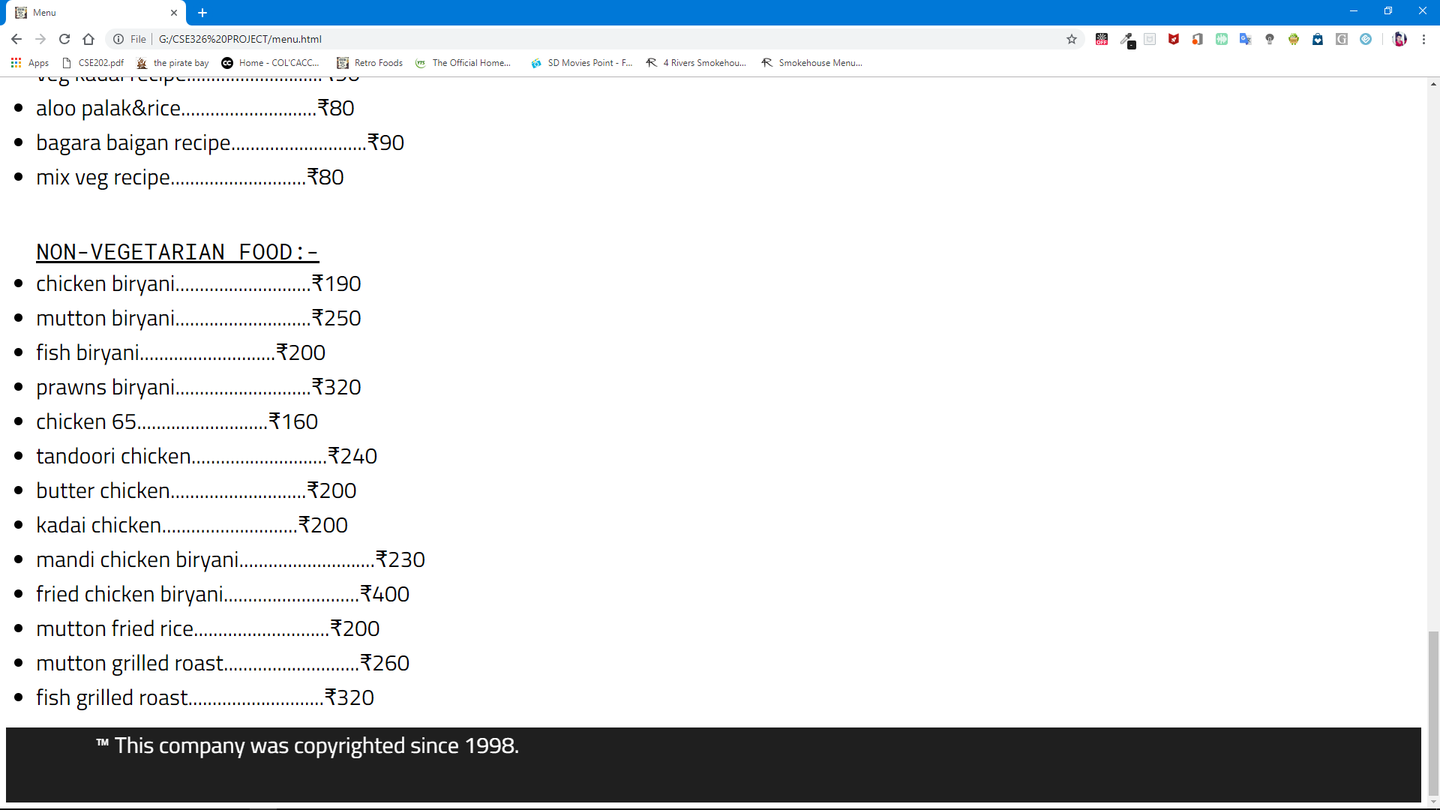

**5.reserving & Homedelivery:-**

This page is for checking and booking by making forms

<input class="first" type="text" placeholder="NAME" name="firstname" id="fn"></p>

<p> items:<textarea placeholder="enter the dishes you want" rows="8" cols="80" class="last" id="ln"></textarea> </p>

<p>address : <textarea placeholder="enter the location" rows="8" cols="80" class="last" id="ln"></textarea> </p>

<p id="pas">Phone number: <input id="password" type="numbers" name="" placeholder="mobile number"> </p>

<p>date of booking <input class="dob" type="date" placeholder="dd/mm/yyyy" name="dob"> </p>

<p>Gender:

<select class="gen" name="gender">

<option value="male">MALE</option>

<option value="female">FEMALE</option>

<option value="others">OTHERS</option>

</select>

</p>

<p id="boxch"> <input type="checkbox" class="check">i agree <a href="http://www.google.com/" color="white" id="boxch"><ins>to rules and conditions.</ins></a> </p>

<p align="center"> <button id="submit" class="submit" type="submit" name="button">Submit</button> </p>

</form>

**The output is:-**

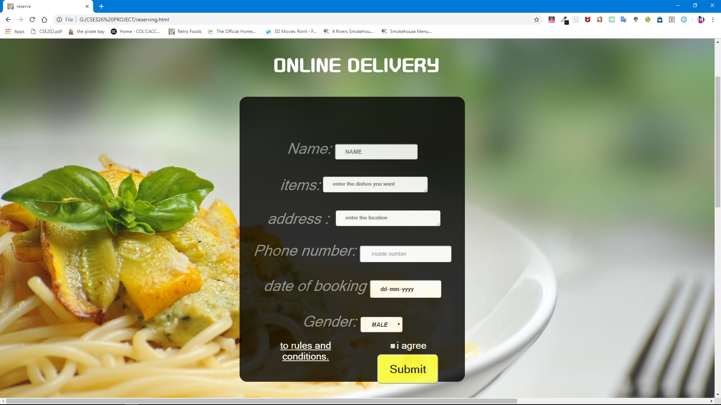

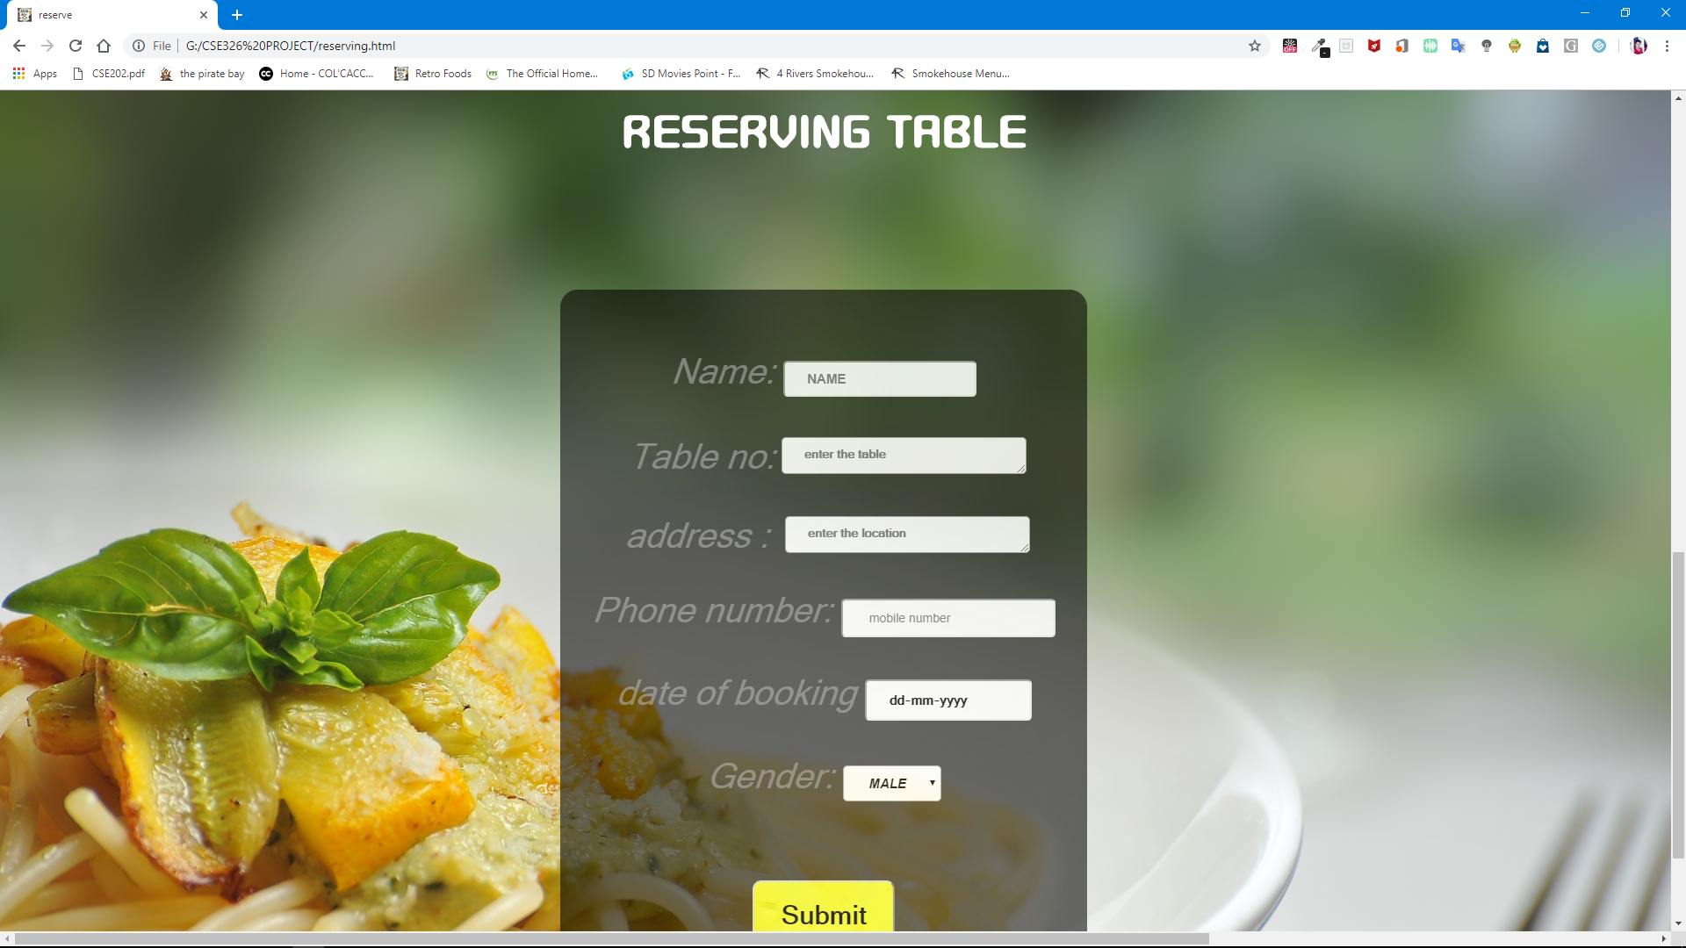

**6.CONTACT US:-**

This page indicates the details about the retro in this

all the details such as contact numbers and emails where customers

can clarify the doubts related to any issues of booking and payment.

In this project I used some paragraph tags and heading tags to put the

details.

The code for this page is:

<p><span id=sp1>Customer Care Numbers :</span>0755-6610661, 0755-4090600

(Language: Hindi and English)</p>

<p><b>For Restaurant table booked through website</b></p>

<p><b>General Information</b></p>

<p><b>e-booking : </b><ahref="#">care@retro.co.in</a></p

<p><b>For Cancellation of tickets : </b> </p>

<p><b>For home delivery </b> <a

href="#">[homedelivry@retro.co.in</a></p](mailto:homedelivry@retro.co.in%3c/a%3e%3c/p)>

The output is:

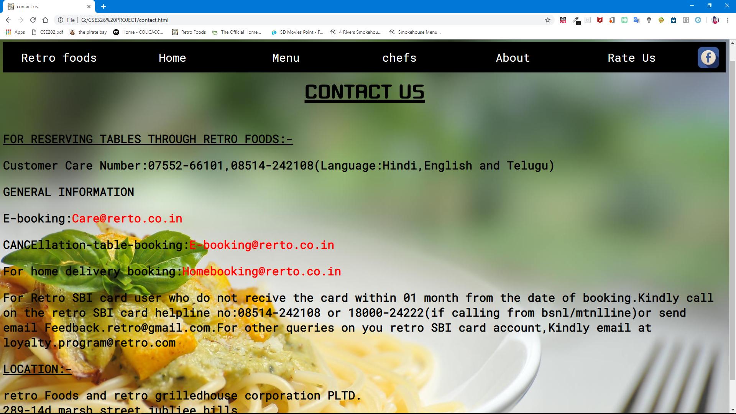

**7.RATE US:-**

This page indicates the feedback form and by this they can improve

the needs.

In this project we are given a module called rate us where the

customers can give their rating out of five and feedback description.

The code used is :

Mainly the radio button

<p>1<input type="radio" name="hi " value="hi"></p>

<textarea name="name" rows="8" cols="80" placeholder="please give ur valuble

feedback"></textarea>

The output is:

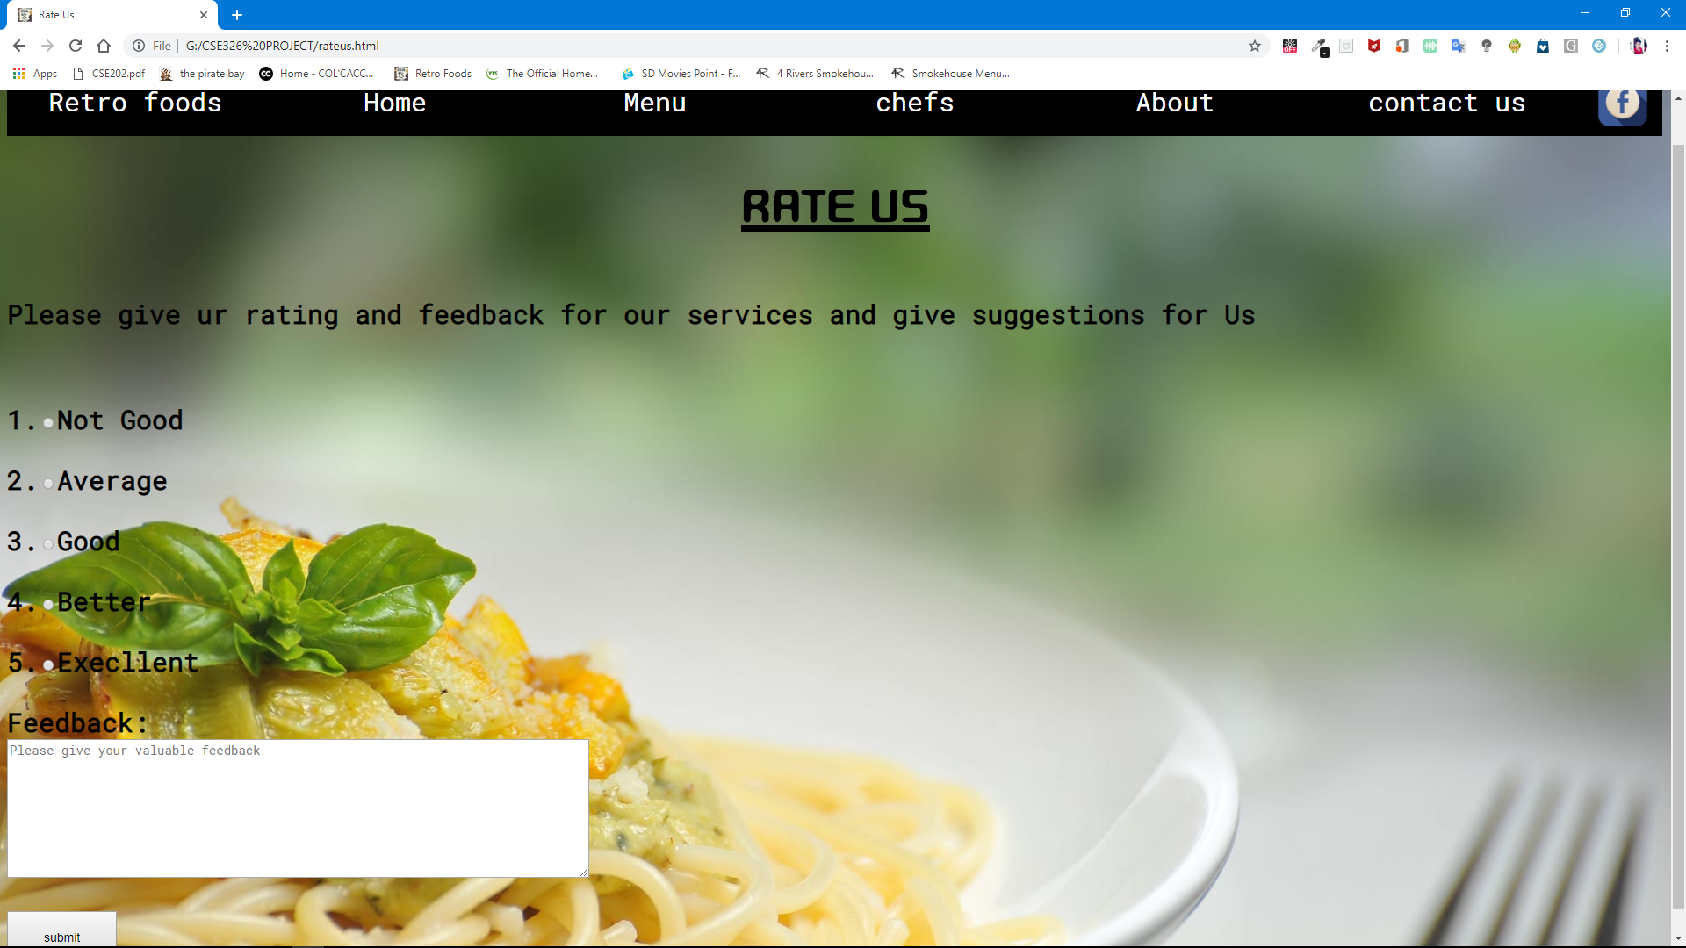

All these modules are inter linked to the homepage.

The code used to link any page to other page is given by :

<link rel href=”name of page.html”> for html

<link rel href=stylesheet type=”text/css” >

DESCRIPTION OF WORK DIVISION IN TERMS OF ROLES

AMONG STUDENTS:-

In this project ,total no of students are three.

One of the three has contribution of creating a homepage and rate us

and contact us and some main modules .i.e reg no:11802400

Second one is done with html and css i.e reg no:11801541

Third one is done participated in the project as html and css i.e reg.no:11805848

IMPLEMENTATION OF SCHEDULED WORK OF

PROJECT:-

The work is divided and scheduled by using ghantt chart which describes the

work division with the help of bar graphs.

By taking the no of days along the x-axis and work division on the y-axis.

The following ghantt chart represents the work division;

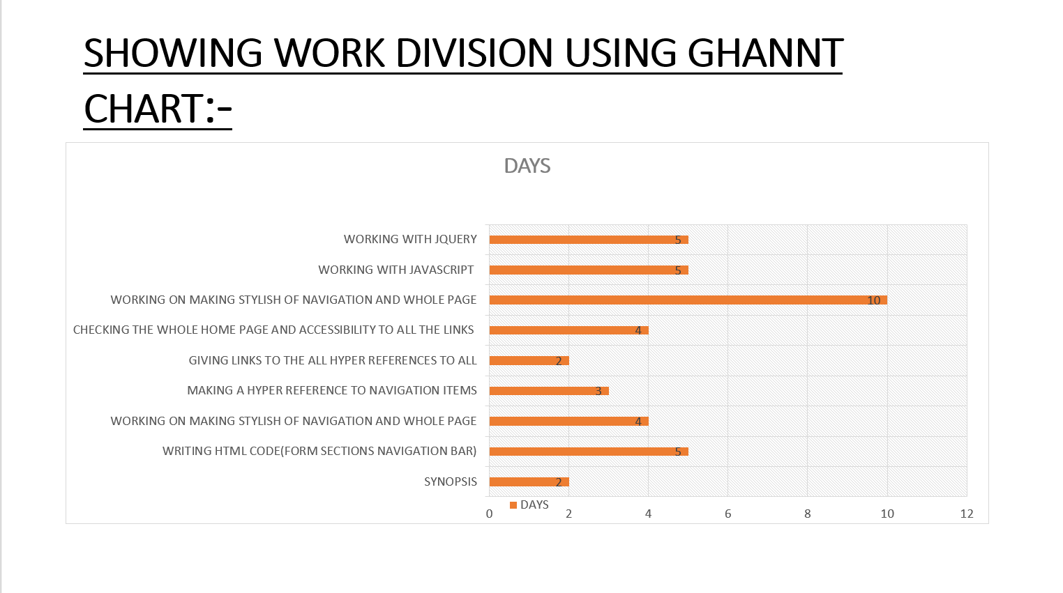

ANALYSIS:-

The project is analysed interms Strengths, Weaknesses, Opportunities and

Threats which called as SWOT analysis.

STRENGTHS:

* The safety and secured data other than the others.
* Easy and time reduceble.
* Technological advanced.
* Luxurious.

WEAKNESS:-

* The main weakness in this project is servers.
* Database management
* Payment method.

OPPURTUNITIES:-

* Accessible at any where in anytime.
* They can modify the data

THREATS:-

* The main threat is in payment section.
* This cannot in the case in the offline.

CONCLUSION:-

* Finally we completed our project, and there are some issues in the project

example payment mode.

* We should take care about the threats and safety measures.
* By using this online reservation system of Retro online restaurant page:
* We can reduce the paper waste.
* It is data secure.

**Thank You!!**